**Index:**

|  |  |  |
| --- | --- | --- |
| S.No | Operator | Page No. |
| 1 | Load datasets | 2 |
| 2 | Filter(basic) | 5 |
| 3 | Filter & Foreach | 6 |
| 4 | Bagging | 7 |
| 5 | Group & Group all | 8 |
| 6 | Split | 9 |
| 7 | Store | 10 |
| 8 | Order | 11 |
| 9 | Join | 12 |
| 10 | Bag | 13 |

**PIG**

**Ravella Abhinav**

**CB.EN.U4CSE19453**

**Load datasets:**

**Airlines:**

**Query:**

airline = LOAD '/home/hduser/Downloads/airports_mod.dat' using PigStorage(',') as (airlineID:charArray,airline_name:charArray, airline_alias:charArray, airline_iata:charArray, airline_icao:charArray,callsign:charArray,territory:charArray, active:charArray);

**Output:**

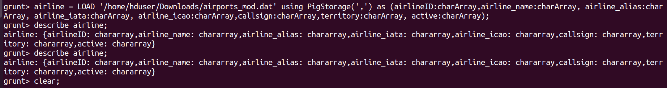

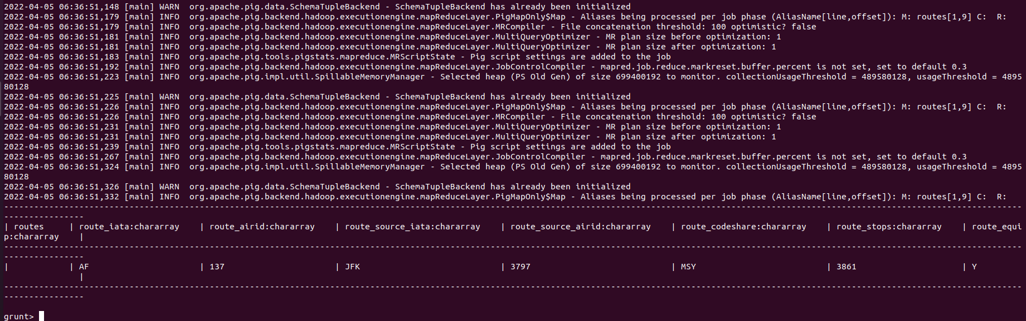

**Final Airlines:**

**Query:**

final = LOAD '/home/hduser/Downloads/Final_airlines' using PigStorage(',') as (airlineID:charArray,airline_name:charArray, airline_alias:charArray, airline_iata:charArray, airline_icao:charArray,callsign:charArray,territory:charArray, active:charArray);

**Output:**



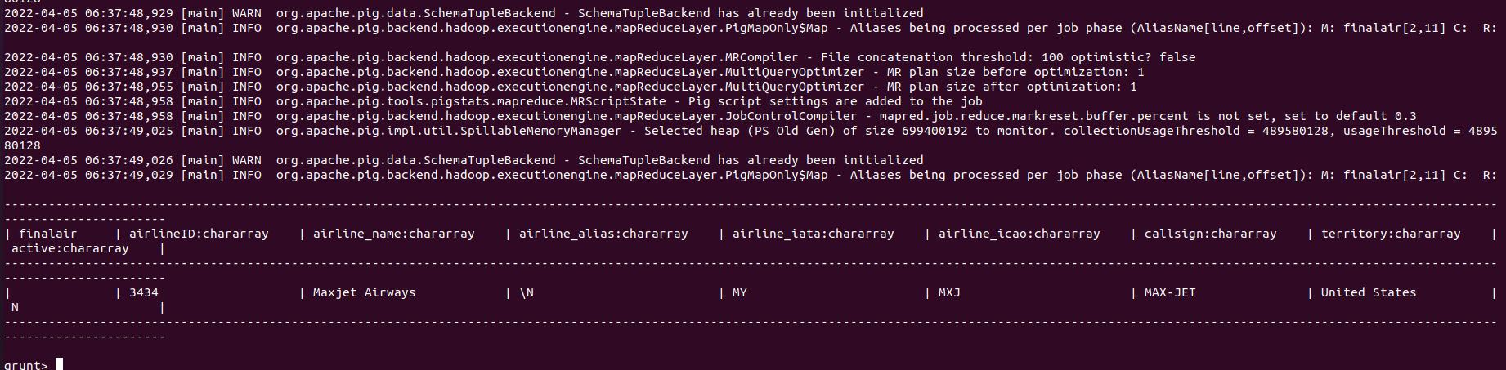

**Routes:**

**Query:**

routes = LOAD '/home/hduser/Downloads/routes' using PigStorage(',') as (route_iata:charArray, route_airid:charArray, route_source_iata:charArray, route_source_airid:charArray, route_codeshare:charArray, route_stops:charArray, route_equip:charArray);

**Output:**

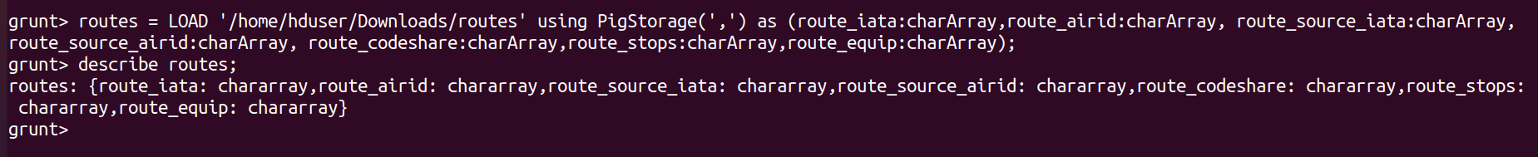

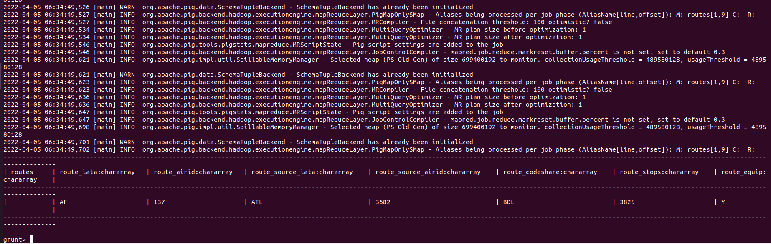

**Queries:**

1. **Find the airlines that are active:**

* active = filter final by Active == 'Y';
* limit = LIMIT active 50;
* dump active;
* dump limit;

**Output:**

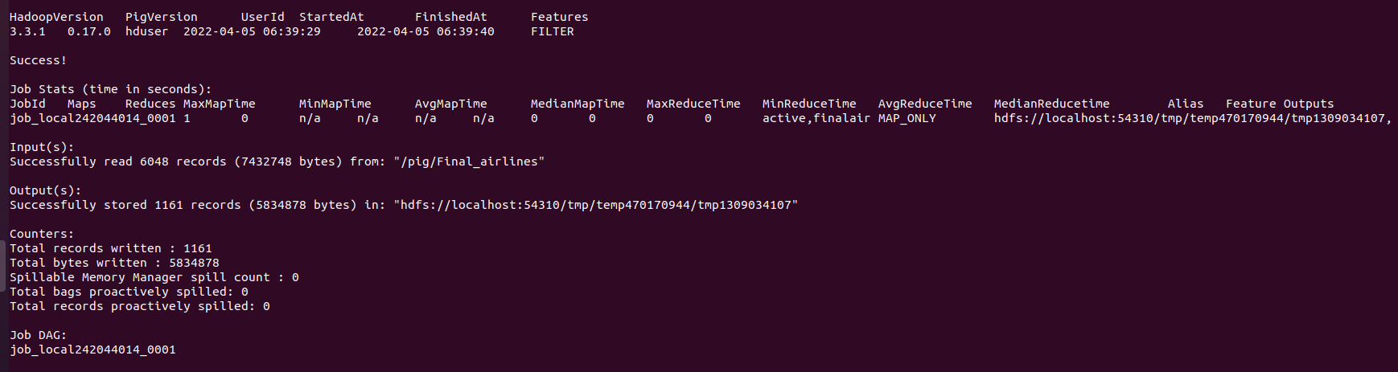

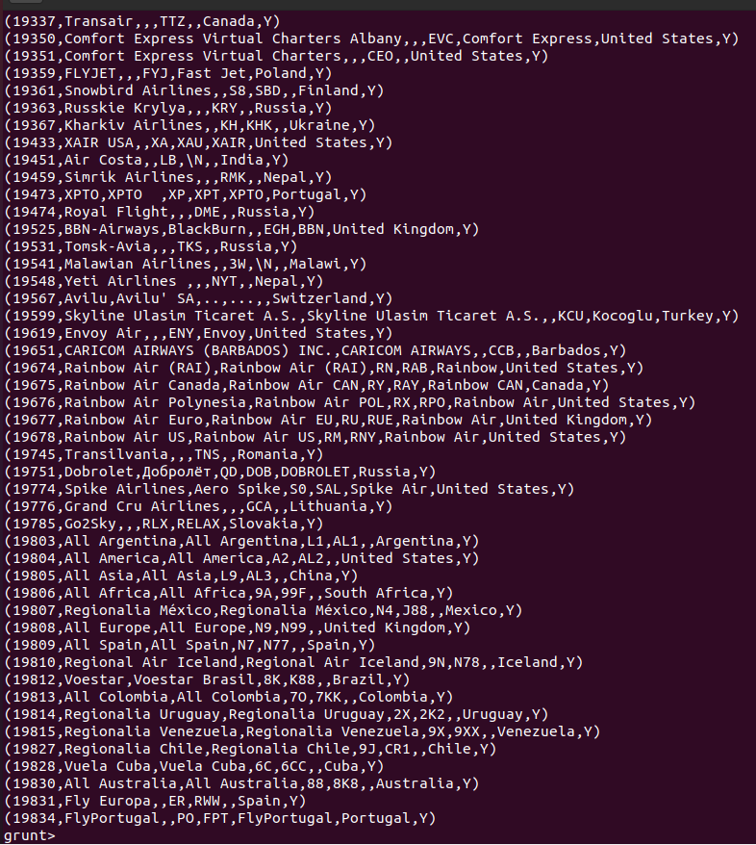

1. **Find the names of active airlines in territory ‘Unites States’?**

Query:

* active_airlines = filter finalair by active == 'Y';
* active_airlines_usa = filter active_airlines by territory == 'United States';
* find_active_airline_names_in_usa = foreach active_airlines_usa generate airline_name;
* dump find_active_airline_names_in_usa;

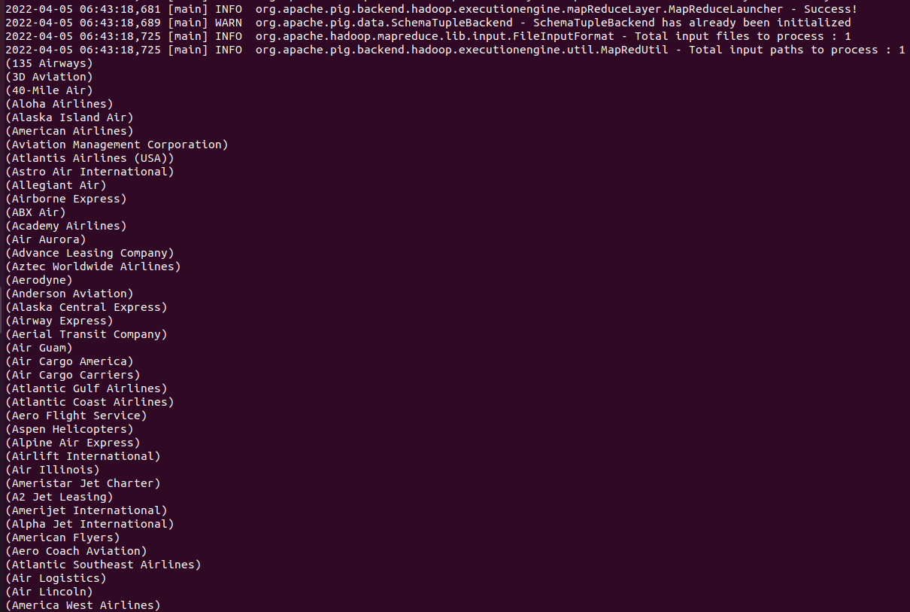

**Explanation:**

Job is to find all the airlines that are active in the United States which are currently active. So first filtering all the airlines that are active using filter and by keywords and saving them in a table and then querying that table to check for the United States territory using the same keywords and printing the airline names only using foreach and generate keywords.

1. **Get all the alias names of all airlines with airlineID**

**Query:**

* foreach_data = FOREACH finalair GENERATE airlineID,airline_name,airline_alias;
* dump foreach_data;

**Output:**

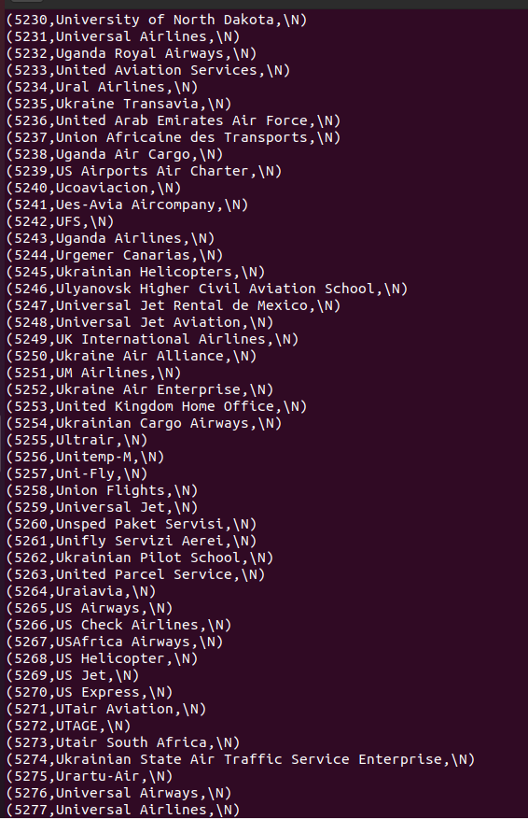

1. **Exploring group command:**

**Query:**

* Group_data = GROUP routes BY (route_iata,route_airid);
* Limit_group = LIMIT Group_data 10;
* Dump Limit_group;
* group_all = GROUP routes All;

**Output:**

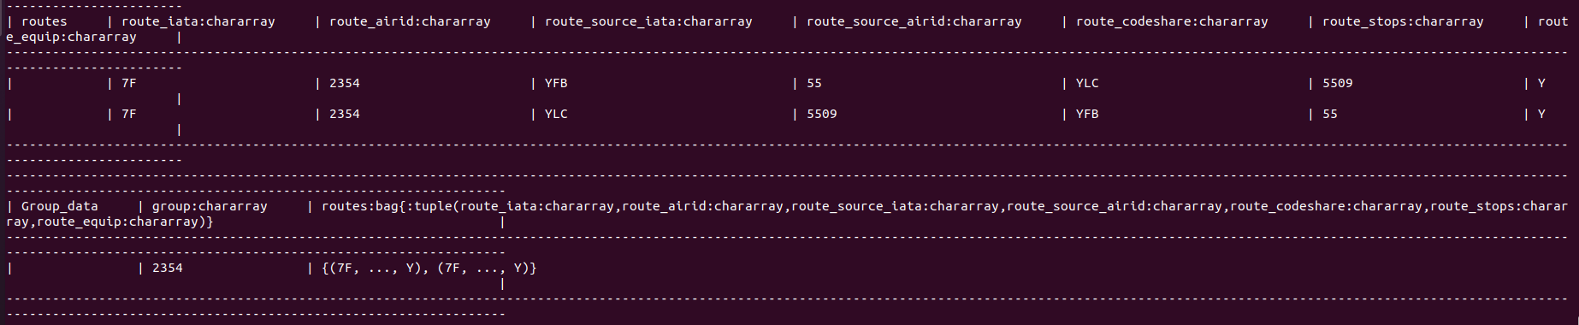

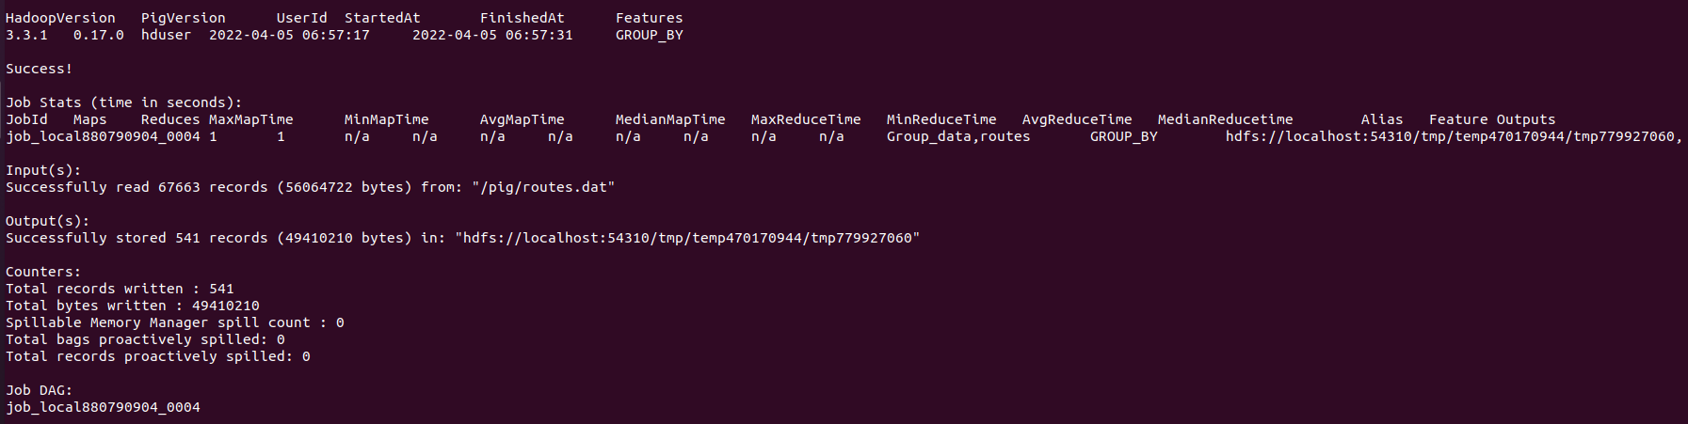

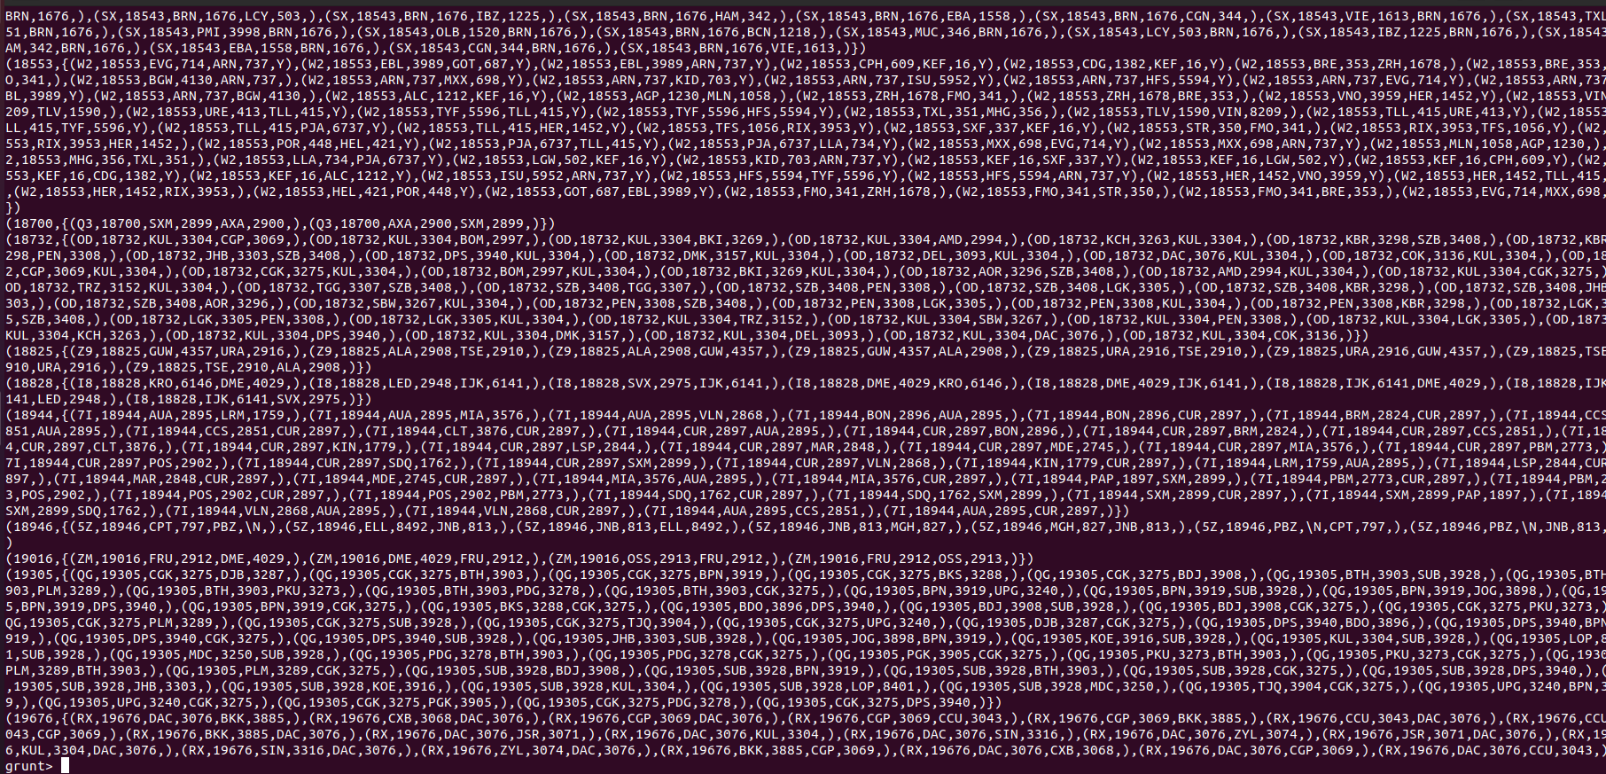

1. **Group airline id by active status;**

**Query:**

* ae = group finalair by airlineID;
* ans = limit ae 10;
* illustrate as;
* dump as;

**Output:**

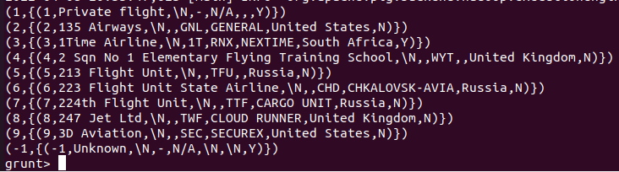

1. **Split relation based on src airport id i.e, equal to DME to get exclusive info.**

**Query:**

* split routes into ru_dme if route_source_iata == 'DME' , ru_not_dme if route_source_iata != 'DME';
* dump ru_dme;
* dump ru_not_dme;

**Output:**

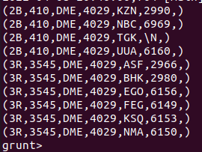

**Explaination:**

* We are trying to split our relation routes in source airport as DME and not equal to DME using split operator.

1. **Store ru_dme relation into text file separated by delimiter “,”.**

**Query:**

* store ru_dme into '/pig/routes_dme.txt' using PigStorage(',');

**Output:**

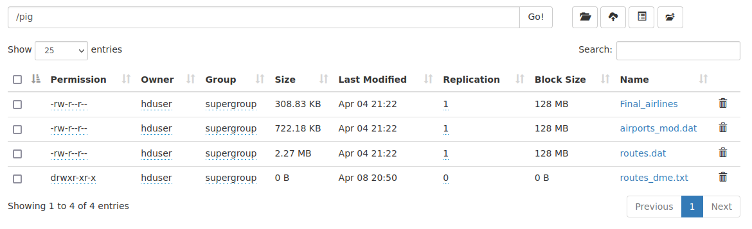

1. **Find the flights that has most number of stops?**

**Query:**

* stops = ORDER routes by route_stops DESC;
* dump stops;

**Output:**

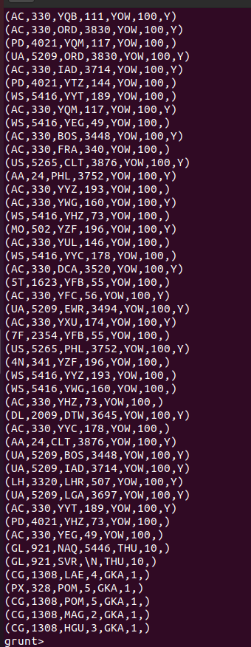

1. **JOIN Command:**

**Query:**

* right_join = JOIN finalair BY airline_iata RIGHT OUTER, routes BY route_iata;
* LIM = LIMIT right_join 10;
* dump LIM;

**Output:**

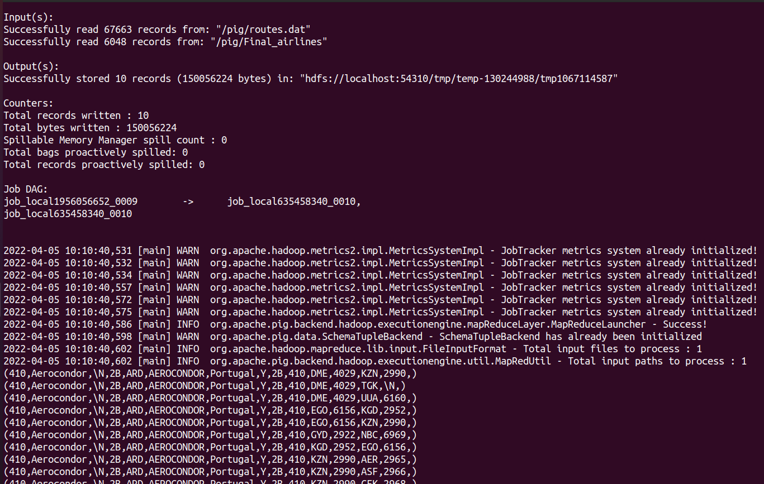

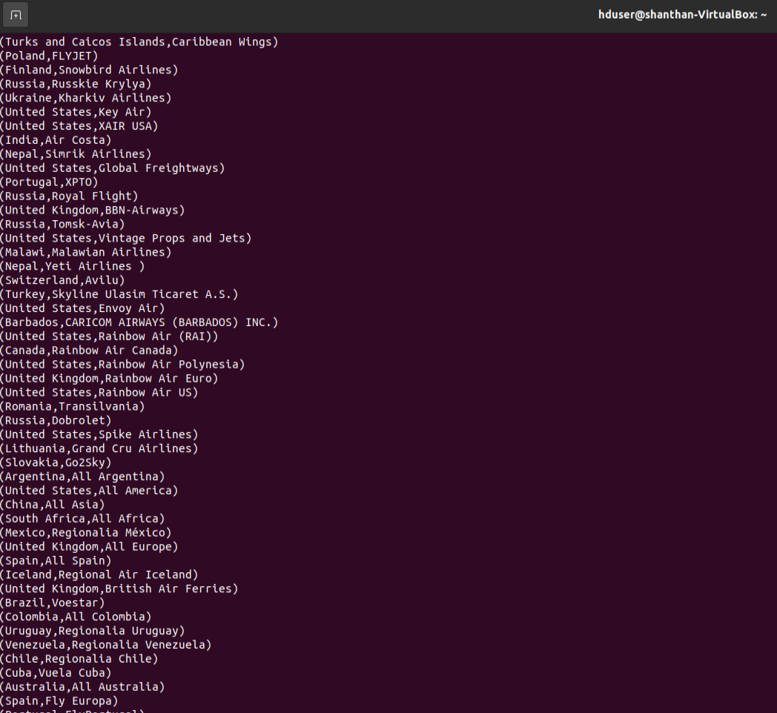

1. **Bag source,dest airport and airline.**

* baged_airline = foreach routes generate TOBAG(route_iata,route_source_airid,route_codeshare);
* bg = limit baged_airline 10;
* dump bg;

